CC Mini Project Report

**Title:**

Chirp : Simple Blogging MEAN stack webapp.

**Abstract:**

The project implements Storage as a Service by storing the Tweet objects in AWS S3 bucket.

Project is implemented using MEAN stack(MongoDb, ExpressJS,AngularJS,NodeJS.

Users can upload Tweets on Chirp and other users can stream it on their browsers.

The allowed Tweet file format is MP4.At any point of time user can delete the Tweets uploaded by him.

**Introduction:**

The project is Tweet streaming web application where users can upload Tweets and stream it at any point.The uploader is able to see how many users have viewed its Tweets.Users can like ,dislike the Tweets.only uploader can delete and edit the Tweet title and description of Tweet.

**Implementation details:**

The whole project is implemented in MEAN stack which are javascript frameworks .Chirp is hosted on Amazon Web Services.HTML is used to create basic template for website,angularjs is used for dynamicity in to website creating a single page web application.In backend MongoDB is used for storing users information and Tweets details.

File stack api is used to store Tweets on the cloud and retrieve the Tweet from the cloud.

File stack provides CDN link for each Tweet and the Tweet cdn link along with other details of Tweets are stored in mongodb database.

MEAN stack web application is executed in amazon EC2(Elastic Cloud Computing) instance.

Mlabs mongodb instance is used as DAAS(Database as a Service).

**Github code link:** [https://github.com/sachdevnitin19/Chirp.git](https://github.com/sachdevnitin19/mytube.git)

**Code:**

Index.html

<html>  
 <head>  
 <title>Chirp</title>  
 <script src="https://ajax.googleapis.com/ajax/libs/angularjs/1.2.0/angular.js"></script>  
 <script src="https://ajax.googleapis.com/ajax/libs/angularjs/1.2.0/angular-route.js"></script>  
 <script src="https://ajax.googleapis.com/ajax/libs/angularjs/1.2.0/angular-resource.js"></script>  
 <script src="javascripts/chirpApp.js"></script>  
 <link rel="stylesheet" type="text/css" href="stylesheets/bootstrapcerulean.css">  
 <link rel="stylesheet" href="stylesheets/style.css">  
 </head>  
 <body ng-app="chirpApp">  
 <div id='main' class="container">  
 <nav class="navbar-fluid navbar-default navbar-fixed-top">  
 <div class="container">  
 <a class="navbar-brand" href="#"> Chirp! </a>  
 <form class="navbar-form navbar-right" ng-submit="search(user)">  
 <div class="form-group">  
 <input type="text" placeholder="Search user..." class="form-control" ng-model="user">  
 <button type="submit" class="btn btn-default" style="width: 46px;height: 38px;">  
 <span class="glyphicon glyphicon-search"></span></button>  
 </div>   
 </form>  
 <p class="navbar-right navbar-text" ng-hide="authenticated" ><a style="color:#ffffff !important;" href="#/login">Login</a> or <a style="color:#ffffff !important;" href="#/register">Register</a></p>  
 <p class="navbar-right navbar-text" ng-show="authenticated"><a style="color:#ffffff !important;" href="#" ng-click="signout()">Logout</a></p>  
 <p class="navbar-right navbar-text" style="color:#ffffff !important;" ng-show="authenticated">Signed in as {{current_user}}</p>   
 </div>  
 </nav>  
 <div class="col-md-offset-2 col-md-8">  
 <div ng-view>  
 </div>  
 </div>  
 </div>  
 </body>  
</html>

**ScreenShots:**

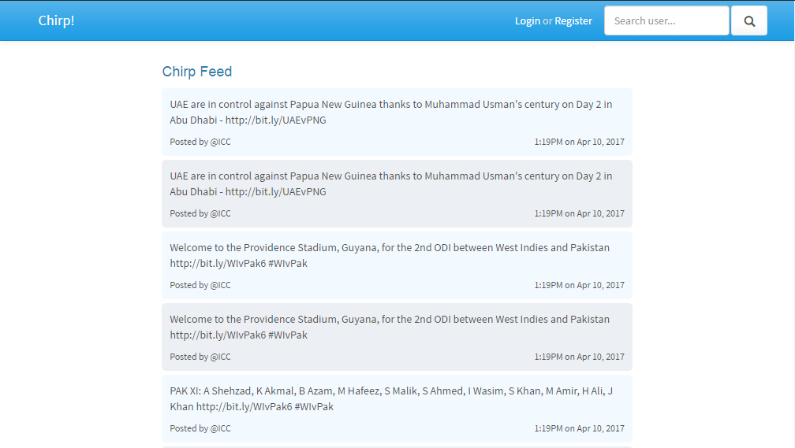

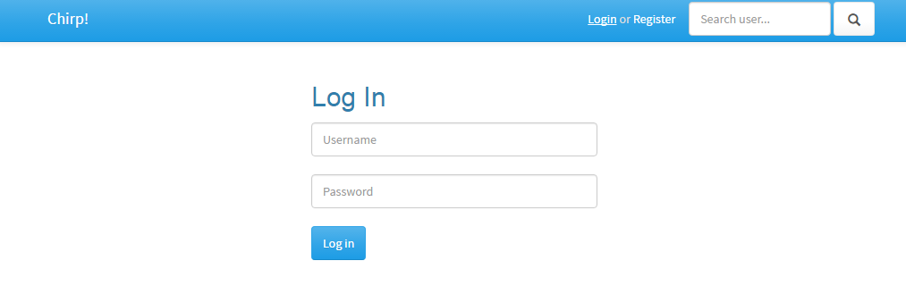

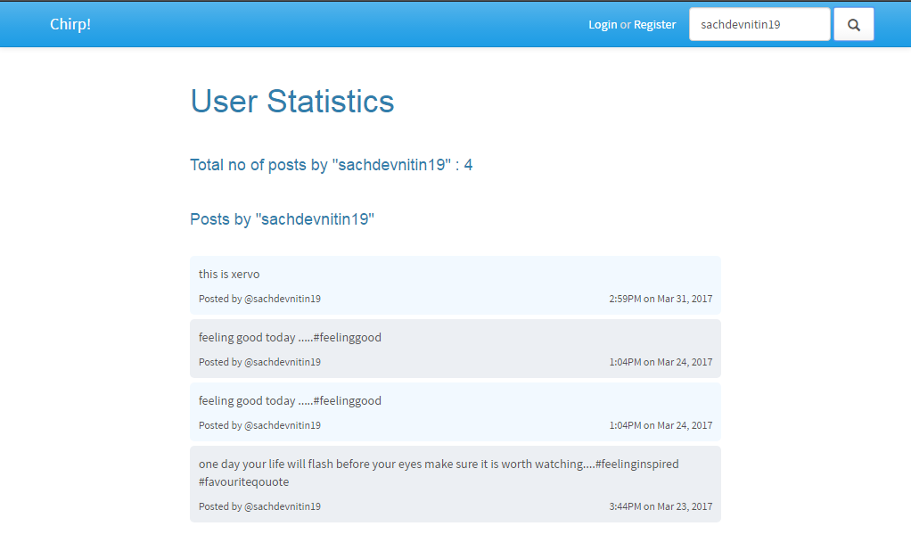

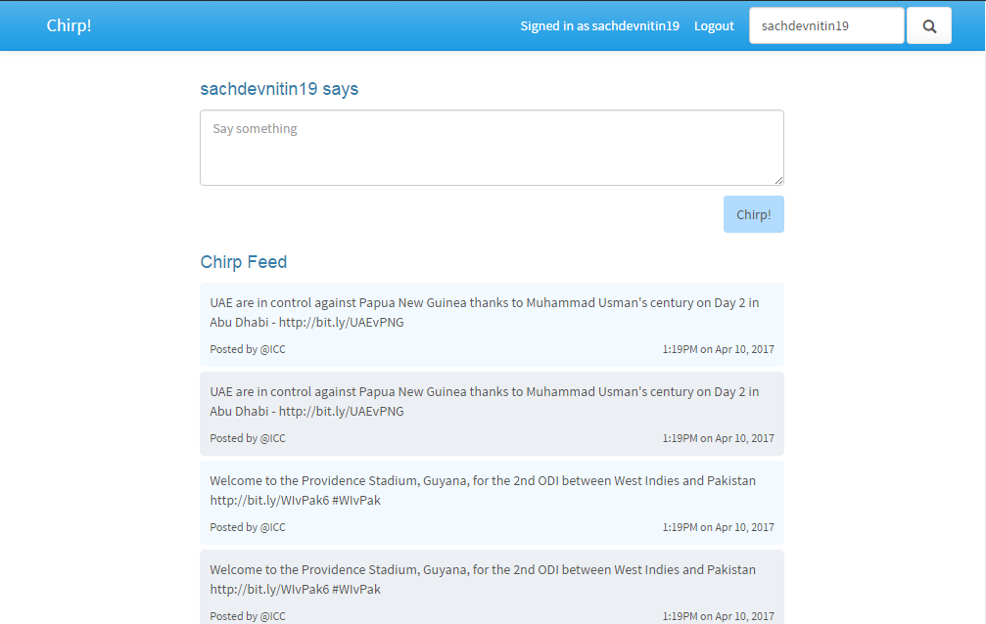

**AWS Link:**

https://ec2-52-221-249-243.ap-southeast-1.compute.amazonaws.com:3000

**Conclusion:**

A Cloud storage system for Tweet storage and Retrieval was successfully implemented and hosted on AWS Cloud services.